Year 11 Revision Questions - Language

Paper 1: Animal Farm
Mr. Jones, of the Manor Farm, had locked the hen-houses for the night, but was too drunk to remember to shut the pop-holes. With the ring of light from his lantern dancing from side to side, he lurched across the yard, kicked off his boots at the back door, drew himself a last glass of beer from the barrel in the scullery, and made his way up to bed, where Mrs. Jones was already snoring.
As soon as the light in the bedroom went out there was a stirring and a fluttering all through the farm buildings. Word had gone round during the day that old Major, the prize Middle White boar, had had a strange dream on the previous night and wished to communicate it to the other animals. It had been agreed that they should all meet in the big barn as soon as
Mr. Jones was safely out of the way. Old Major (so he was always called, though the name under which he had been exhibited was Willingdon Beauty) was so highly regarded on the farm that everyone was quite ready to lose an hour's sleep in order to hear what he had to say.
At one end of the big barn, on a sort of raised platform, Major was already ensconced on his bed of straw, under a lantern which hung from a beam. He was twelve years old and had lately grown rather stout, but he was still a majestic-looking pig, with a wise and benevolent appearance in spite of the fact that his tushes had never been cut. Before long the other animals began to arrive and make themselves comfortable after their different fashions. First came the three dogs, Bluebell, Jessie, and Pincher, and then the pigs, who settled down in the straw immediately in front of the platform. The hens perched themselves on the window-sills, the pigeons fluttered up to the rafters, the sheep and cows lay down behind the pigs and began to chew the cud. The two cart-horses, Boxer and Clover, came in together, walking very slowly and setting down their vast hairy hoofs with great care lest there should be some small animal concealed in the straw. Clover was a stout motherly mare approaching middle life, who had never quite got her figure back after her fourth foal.
Boxer was an enormous beast, nearly eighteen hands high, and as strong as any two ordinary horses put together. A white stripe down his nose gave him a somewhat stupid appearance, and in fact he was not of first-rate intelligence, but he was universally respected for his steadiness of character and tremendous powers of work. After the horses came Muriel, the white goat, and Benjamin, the donkey. Benjamin was the oldest animal
on the farm, and the worst tempered. He seldom talked, and when he did, it was usually to make some cynical remark--for instance, he would say that God had given him a tail to keep the flies off, but that he would sooner have had no tail and no flies. Alone among the animals on the farm he never laughed. If asked why, he would say that he saw nothing to laugh at.
Nevertheless, without openly admitting it, he was devoted to Boxer; the two of them usually spent their Sundays together in the small paddock beyond the orchard, grazing side by side and never speaking. The two horses had just lain down when a brood of ducklings, which had lost their mother, filed into the barn, cheeping feebly and wandering from
side to side to find some place where they would not be trodden on. Clover made a sort of wall round them with her great foreleg, and the ducklings nestled down inside it and promptly fell asleep. At the last moment Mollie, the foolish, pretty white mare who drew Mr. Jones's trap, came mincing daintily in, chewing at a lump of sugar. She took a place near the front and began flirting her white mane, hoping to draw attention to the red ribbons it was plaited with. Last of all came the cat, who looked round, as usual, for the warmest place, and finally squeezed herself in between Boxer and Clover; there she purred contentedly throughout Major's speech without listening to a word of what he was saying.
All the animals were now present except Moses, the tame raven, who slept on a perch behind the back door. When Major saw that they had all made themselves comfortable and were waiting attentively, he cleared his throat and began:
"Comrades, you have heard already about the strange dream that I had last night. But I will come to the dream later. I have something else to say first. I do not think, comrades, that I shall be with you for many months longer, and before I die, I feel it my duty to pass on to you such wisdom as I have acquired. I have had a long life, I have had much time for thought as I lay alone in my stall, and I think I may say that I understand the nature of life on this earth as well as any animal now living. It is about this that I wish to speak to you.
Q1. Read again the first paragraph of the source.
List four things that Farmer Jones does before falling asleep. (4 marks)

Q2. How does the writer use language in paragraphs 2, 3 and 4 to describe the animals?
You could include the writer’s choice of:
- Words and phrases
- Language features and techniques
- Sentence forms (8 marks)

Q3. You now need to think about the whole of the text.
This text is from the opening of a novel.
How has the writer structured the text to interest you as a reader?
You could write about:
- What the writer focuses your attention on at the beginning
- How and why the writer changes this focus as the extract develops
- Any other structural features that interest you. (8 marks)

Q4. A student, having read this text said: “The writer brings the characters to life to the reader. It is as if you are there with them.”
To what extent do you agree?
In your response, you could:
- Write about your own impressions of the characters
- Evaluate how the writer has created these impressions
- Support your opinions with quotations from the text.
(20 marks)

Paper 1 Section B: Narrative and Descriptive Writing
You are advised to spend about 45 minutes on this section.
Write in full sentences.
You are reminded of the need to plan your answer.
You should leave enough time to check your work at the end.

You are going to enter a creative writing competition.
Your entry will be judged by a panel of people of your own age.

Either: Write a description suggested by this picture:

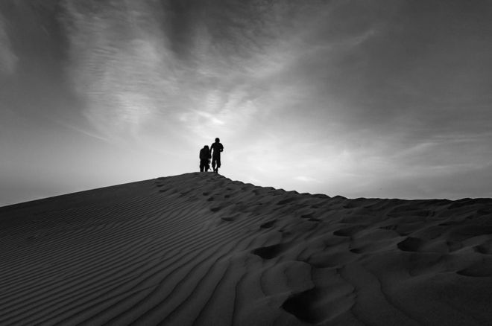

Or: Write the opening part of a story about a journey.
(24 marks for content and organisation
16 marks for technical accuracy)
[40 marks]

Paper 1 Section B: Narrative and Descriptive Writing
You are advised to spend about 45 minutes on this section.
Write in full sentences.
You are reminded of the need to plan your answer.
You should leave enough time to check your work at the end.

You are going to enter a creative writing competition.
Your entry will be judged by a panel of people of your own age.

Either: Write a description suggested by this picture:

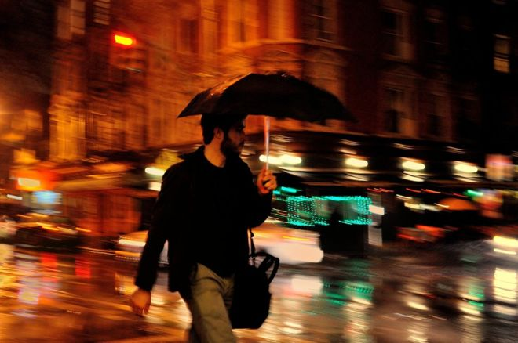

Or: Write the opening part of a story about a character who is late.
(24 marks for content and organisation
16 marks for technical accuracy)
[40 marks]

Paper 1 Section B: Narrative and Descriptive Writing
You are advised to spend about 45 minutes on this section.
Write in full sentences.
You are reminded of the need to plan your answer.
You should leave enough time to check your work at the end.

You are going to enter a creative writing competition.
Your entry will be judged by a panel of people of your own age.

Either: Write a description suggested by this picture:

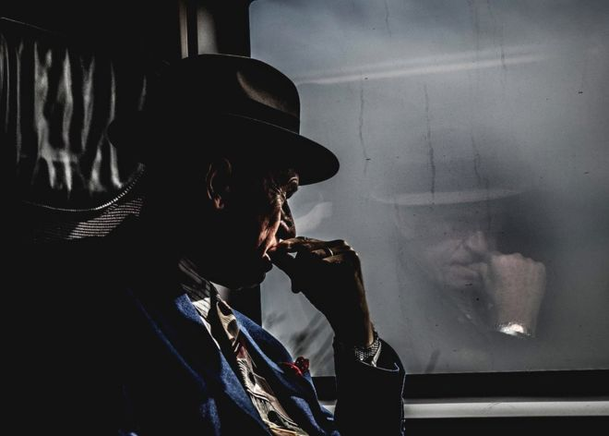

Or: Write the opening part of a story about a character who regrets something.
(24 marks for content and organisation
16 marks for technical accuracy)
[40 marks]

Paper 2:
Source A
British climber, Matt Dickinson, together with his team, is attempting to scale Mount Everest. At base camp, a thousand feet below them, his colleague, Audrey Salkeld is the first to see the approaching storm.
The Death Zone
At 5,360 metres, base camp is a cheerless place at the best of times, but once the sun has dipped beneath the surrounding ridges, it is like living in a freezer. Shivering with the cold, Salkeld left the mess tent and walked across the ice of the Khumbu glacier towards her tent to find some extra clothing.
Glancing into the sky to the south, she became one of the first people, and probably the very first, to see what was sweeping up from the lower valleys of the Himalayas towards Everest. It was a sight which fixed her to the spot, all thoughts of seeking out a few more layers of clothing momentarily forgotten.
Sudden squalls are common in the afternoon on Everest but Salkeld had never seen anything like this before. She later described it as looking like a tyre dump fire, great billowing lilac clouds racing up from the south. She called out other members of the team from our tents, and they stood watching in awe as the apocalyptic vision crept silently and swiftly towards them.
At speeds touching 80 to 100 kilometres an hour, the storm whipped into the camp just minutes later, plunging the temperature down by ten to fifteen degrees in as many seconds, ripping into the tents in a blinding fury of driving snow. The storm swept up the southern flanks of Everest engulfing the ice-clad slopes effortlessly in a swirling mantle of hurricane-force winds. Within minutes it had the northern side in its grip and then it rose to take the summit. The mightiest mountain in the world disappeared from view as the storm took control.
If Shiva, the Hindu god of destruction, and Nemesis, the Greek goddess of retribution, had joined forces they could not have done a better job of devastation than nature itself did on that day. The timing was uncanny, as bad as it was possible to be. If the storm had struck in winter then no one would have been hurt. But as chance would have it, the tempest1 arrived on the busiest day of the Everest calendar, right in the middle of the pre-monsoon climbing season.
Our expedition, a British attempt on the North Face via the North-East Ridge, was at camp three when the storm thundered in.
We immediately knew that this was something far more dangerous than any other storm that had hit us in the eight weeks we had been there. The temperature fell to ten degrees below freezing, then twenty, then thirty degrees below. The wind became a constant, bullying force, pulling guy ropes from the glacier ice, tumbling fully-laden equipment barrels into crevasses and demolishing our canvas mess tent with frightening ease. The dome tents, built to withstand hurricane-force winds, creaked and groaned under the beating, distorted into shapes they were never designed for and straining the tent poles to their limits.
We could have been in the Antarctic, on the Greenland ice cap, or at the North Pole, so complete was the blanket of driving snow which obscured every feature around us. Not a single landmark, not even the huge North Ridge, was visible through the raging white-out of the blizzard.
Through the white wall of snow, and rising across the tempestuous roar of the wind across the glacier was another sound: a sinister howl which told of even greater powers at play in the altitudes above us; the scream of the storm as it whirled across the North Face at 8,000 metres and above.
British climber, Matt Dickinson, together with his team, is attempting to scale Mount Everest. At base camp, a thousand feet below them, his colleague, Audrey Salkeld is the first to see the approaching storm.
There, in the ‘Death Zone’, more than thirty climbers were fighting for their lives. On the northern side three Indian climbers were stranded, exhausted and with their oxygen supplies running out, high on the North-East Ridge. On the southern side, two commercial expeditions were strung out between the South Col2 and the summit.
The night that faced them was a night from hell. By the end of the following day, the three Indian climbers on the north side and five of the climbers on the south were dead. The total of eight fatalities made this the greatest loss of life in any twenty-four hour period on the peak.
Glossary:
tempest1 – storm
South Col2 – a mountain path

Source B
Arthur Munby kept a diary in the 1800s, and in these extracts, taken from January 1867, he describes London in the snow.
London Snow
Wednesday, 2 January. Since midnight, snow had silently fallen, to the depth of six to eight inches; by breakfast time it was all over except a slight flaky dropping, and the day was calm and very cold. Nothing could be more beautiful; no change more complete and charming. The trees around the fountain near Garden Court were loaded with snow: an exquisite tracery of white branches, relieved against the dark red house fronts.
But in the streets the transformation was greatest. All traffic, except afoot, was stopped; no cabs, no omnibuses, no wagons. The snow lay in heaps in the road; men were scraping and shovelling the footways; and people in thick coats and wrappers stepped noiselessly along. The Strand was as quiet and empty as a village street at nightfall; even the foot passengers were far fewer than usual.
Here in the heart of London, and at midday, there was absolute cleanliness and brightness, absolute silence: instead of the roar and rush of wheels, the selfish hurry, the dirt and the cloudy fog, we had the loveliness and utter purity of new- fallen snow. It fell without force or sound; and all things huge and hasty and noisy were paralyzed in a moment. I walked along enjoying the wondrous lovely scene, the long perspective of houses, all grown picturesque and antique; their gable roofs white against a clear sky, and every overhanging joint and beam in their outline picked out in brilliant white; and beneath them, the tumbled and peopleless pavement of snow. It was like the quaint still London of old; one might have been arm in arm with Mr. Pepys, or even Mr. W. Shakespeare. And this state of things lasted all day.
There were many crossing sweepers about: I noticed one near Saint Clement Danes, a girl of seventeen or so, in ragged but warm shawl, and a bit of an old bonnet, whose dark rough hair was covered with snow, and hung in a tangled white mass, like the foam of a waterfall, over her brown bonny face, as she stood with her broom under her arm, stamping and blowing her fingers.
Friday, 4 January. The cold out of doors at ten this morning was more intense, to my apprehension, than I ever remember. My beard froze, and the nape of my neck, and my heart seemed paralyzed. A headache came on, and by the end of the short walk from here to Whitehall I was almost helpless.
At 4pm I walked westward, thinking to call on my friends, the Thackerays. The Horseguards Parade and the Mall were one sheet of snow, with paths trodden but not swept: a thick brown fog brooded over it, deepening the twilight; and muffled spectral figures hurried to and fro across the slippery ground. In Victoria Street a girl begged of me: a ragged tall girl of nineteen, by name Caroline Randall, by trade an ironer; who has no home; who slept last night on a step in a sheltered corner, and felt 'as cold as a frog', she said.
Questions:
Read again Source A from lines 1 to 12.
- Choose four statements below which are TRUE. [4 marks]
A Base camp is a cosy and happy place.
B The temperature at base camp drops when the sun goes down.
C Salkeld was so cold that she needed to put on more clothes.
D The storm had hit Everest from the north.
E Salkeld was excited at the sight of the storm.
F Salkeld had often seen storms like this on Everest.
G They watched as the storm got closer to them.
H The approaching storm looked like something from the end of the world.

- You need to refer to Source A and Source B for this question.
The effects of the weather on people in both sources are very different.
Use details from both sources to write a summary of the different ways people are affected by the weather. [8 marks]

- You now need to refer only to Source A from lines 13 to 23.
How does the writer use language to describe the storm? [12 marks]

- For this question, you need to refer to the whole of Source A, together with the whole of Source B.

Compare how the writers convey their different perspectives on the extreme weather conditions.
In your answer, you could:
- Compare their different perspectives on the extreme weather conditions
- compare the methods the writers use to convey their different perspectives
- support your response with references to both texts. [16 marks]

Paper 2 Section B: Writing

You are advised to spend about 45 minutes on this section.
Write in full sentences.
You are reminded of the need to plan your answer.
You should leave enough time to check your work at the end.

‘Violent console games, films and Hip Hop music lyrics encourage young people to commit violent crimes by making this aggressive behaviour seem normal or even glamorous.’

Write a letter to a broadsheet newspaper in response to a recently published article on this subject in which you explain your point of view.

(24 marks for content and organisation
16 marks for technical accuracy)
[40 marks]

Paper 2 Section B: Writing

You are advised to spend about 45 minutes on this section.
Write in full sentences.
You are reminded of the need to plan your answer.
You should leave enough time to check your work at the end.

‘Schools these days put far too much emphasis on the core subjects such as Maths, English and Science meaning that the all-important creative and practical subjects are pushed out.’

Write a speech that will be delivered at an Education conference in which you explain your point of view on this statement.

(24 marks for content and organisation
16 marks for technical accuracy)
[40 marks]

Paper 2 Section B: Writing

You are advised to spend about 45 minutes on this section.
Write in full sentences.
You are reminded of the need to plan your answer.
You should leave enough time to check your work at the end.

‘Obesity in the young has become such a widespread problem, that the government need to take swift and radical action in order to avoid a generation of morbidly obese adults.’

Write an article for a broadsheet newspaper in which you explain your point of view on this statement.

(24 marks for content and organisation
16 marks for technical accuracy)
[40 marks]

