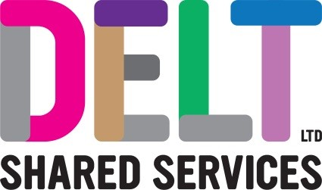

1 Week Work Experience Placements 2020
Delt is a dynamic and agile private sector company with a serious conscience, that’s wholly owned by the public sector. It’s somewhere you can gain a great insight to the world of work and develop your employability skills.

We are looking for enthusiastic students to work alongside our IT and Business Support Professionals. The ideal candidate must be customer focused, an excellent communicator, be a keen and willing learner, with good IT knowledge in their chosen field. You'll have a 'Positive Mental attitude” and be able to show initiative. We have various opportunities across the business.
How to apply;
Please email your CV and Covering letter to recruitment@deltservices.co.uk.
Places are limited.
Group Assessment Centre: Wednesday 19th February
Guidance for applicants
We would ask you to specify within your covering letter the following.
- The school that you attend
- Date of work experience
- Which area of the business you would like to gain experience within.
- Why you would like to undertake your experience with us.
Our group assessment centre we promise will be fun and engaging with a combination of tasks, group activities and Interview.

