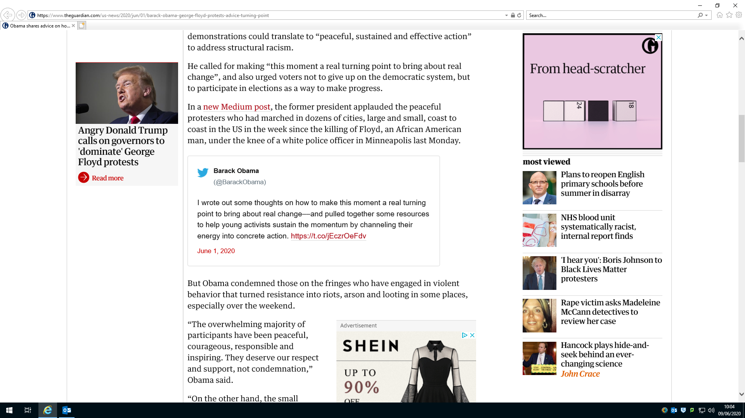
Two presidential views – rather different approaches, Trump using force and Obama using peaceful protest. Consider how each one will have a different impact – in your opinion, which one is better?
Racism has many forms:An Oxford college has ordered staff and students to undergo training to combat racial bias after an undergraduate made a “joke” drawing a comparison between protests over the killing of George Floyd in Minneapolis and flour shortages.
The comments, described as racist and trivialising by witnesses, were made during a virtual hustings event by a candidate for the position of “cake rep” – a welfare position on the junior common room committee at Christ Church College.The student, who has since withdrawn her candidacy, said: “The US is facing two very important crises at the moment – the curious incident of George Floyd, and the event of flour shortage.”
George Floyd: why has this incident been so powerful?Floyd has sparked a wave of “Let’s do this another way”. Those in the majority have stepped forward and have been peacefully protesting. They have taken a knee. This peaceful protest has given hope to many. Not because white people see themselves as allies but because they recognize what it means to be human.
Police kneel down in North Carolina and the protect turns peaceful:
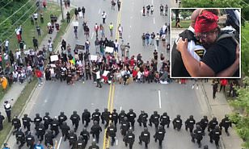
What can we do to lower the levels of racism in our community? What can we do another way? Talking is a great starting point!
Does George Fl;oyd’s criminal background make a difference to the we perceive this event?

