Dr Jekyll and Mr Hyde
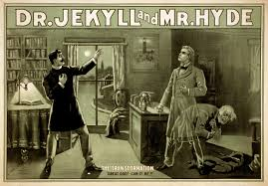

Name:

Class:

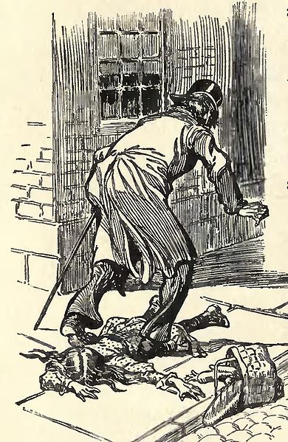
Context Questions
- Which monarch was on the throne when Jekyll and Hyde was published?

- Give one reason a man would want to be a gentleman.

- Which statements about Victorian gentleman is not true?
  - They were vulnerable to blackmail.
  - They did not care about their appearance.
  - They were obsessed with their reputations.

- Give a brief overview of what working-class London would have been like.

- Which branch of Christianity particularly influenced Victorian life?

- Which of these is one of its teachings?
  - Some human beings are naturally sinful.
  - Most human beings are naturally sinful.
  - All human beings are naturally sinful.

- What was the name of Darwin’s famous book on evolutionary theory?

- Give a brief summary of its ideas.

Questions to answer once you have read the book.
- What evidence is there in Jekyll and Hyde that society in Victorian England was religious?

- Using what you know about the period, why might Hyde be particularly frightening for Victorian readers?

1: The story of the door
Summary of the chapter:-
Glossary
Cain’s heresy: refers to Cain murdering his brother Abel.

The very pink of the properties: upright to the highest degree.

Queer Street: imaginary street where people in trouble, financial or otherwise, are supposed to live.

Key points about characters, with quotes.

Key points about themes, with quotes.

Notes on context: eg, Freud, Darwin, Conventions of the gothic novel.

Questions:
- What sort of character is Mr Utterson?

- What evidence is there to suggest that Utterson has a private, hidden side?

- Who is Mr Richard Enfield?

- Enfield and Utterson walk every Sunday. Describe the street that they walk down.

- How is one particular house different from the others on this street?

- In your own words, explain what Enfield saw in his account of the ‘Story of the Door.’

- How do the characters react to the man who trampled over the small girl? (Describe the effect he has on them.)

- Enfield describes the house by commenting that the windows are always shut. Why might this be a significant detail?

- What does Mr Hyde look like? How does Enfield describe him?

Who’s Who in ‘Jekyll and Hyde’?
Dr Henry Jekyll… | Mr Edward Hyde…
Mr Gabriel Utterson… | Dr Hastie Lanyon…
Mr Richard Enfiled… | Poole…
Sir Danvers… | Mr Guest…

2: Search for Mr Hyde
Summary of the chapter:-
Glossary
Holograph: a document written entirely in the handwriting of the person.

Troglodyic: primitive

Statute of limitations: law protecting a person from prosecution after a period of time has elapsed.

Pede caludo: walking hesitantly.

Key points about characters, with quotes.

Key points about themes, with quotes.

Notes on context: eg, Freud, Darwin, Conventions of the gothic novel.

Questions:
- Why does Mr Lanyon disapprove of Dr Jekyll?

- Dr Jekyll and Mr Utterson both have hidden pasts. What are they?

- Find and explain three quotations depicting urban London as a sombre and threatening place.

Extension question: Think back on Stevenson’s contemporaries Darwin and Freud. Can you find anything in the first two chapters that suggests their influence? (Hint: look at the depiction of Hyde and what happens to Utterson after he meets Lanyon).

3: Dr Jekyll quite at ease
Summary of the chapter:-
Glossary

Hide-bound pedant: narrow minded and conventional in thinking.

Key points about characters, with quotes.

Key points about themes, with quotes.

Notes on context: eg, Freud, Darwin, Conventions of the gothic novel.

Questions:
- How is Jekyll shown as a popular, respectable man?

- How does Jekyll respond when Utterson talks to him about his will?

- Find and explain two quotations showing Jekyll has a ‘dark side’.

- The Carew Murders
Summary of the chapter:-
Glossary
Conflagration: fire

Penny numbers: goods which could be bought for a penny.

Slatternly: slovenly, wretched.

Blackguardly: evil looking.

Key points about characters, with quotes.

Key points about themes, with quotes.

Notes on context: eg, Freud, Darwin, Conventions of the gothic novel.

Questions:
- Give four quotes to describe the gruesome detail of Hyde attacking Carew.

- How is the setting key to this chapter?

- How does Hyde’s landlady show the ‘dual nature of man’?

- Incident of the letter
Summary of the chapter:-
Glossary
Cupola: domed roof sometimes containing windows.

Cabinet: private study

Cheval-glass: mirror

Carbuncles: red precious stones.

Key points about characters, with quotes.

Key points about themes, with quotes.

Notes on context: eg, Freud, Darwin, Conventions of the gothic novel.

Questions:
‘“What!” he thought. “Henry Jekyll forge for a murderer!” And his blood ran cold in his veins.’

Think about what Mr Utterson has just found out about Dr Jekyll and the potential forgery he has undertaken.

- How does Mr Utterson react to this news? What is the ‘ticklish decision’ he has to make?

- What does the description of Dr Jekyll in this chapter suggest about his character? How does he behave with Utterson?

- Dr Jekyll appears disturbed in this chapter. Do you think this is the result of Mr Hyde’s influence over Dr Jekyll, or due to Dr Jekyll’s wish to help Mr Hyde? Explore both possibilities and analyse the different viewpoints.

- Remarkable Incident of Dr Lanyon
Summary of the chapter:-
Glossary
Ken: knowledge
Allusion: mention of
Amities: friendship
Predecease: to die before
Mortify: control/subdue

Key points about characters, with quotes.

Key points about themes, with quotes.

Notes on context: eg, Freud, Darwin, Conventions of the gothic novel.

Questions:
- Contrast the earlier description of Dr Lanyon (in ‘Search for Mr Hyde’) with the description of him in this chapter.

- What is it exactly that frightens Dr Lanyon? What does Stevenson suggest he has learnt more about when he says that if we knew all we would be glad to die?

- Track the changes in Dr Jekyll through this chapter.

- i) Where and why does the symbol of the locked door reappear in this chapter?

ii) Find another example of something being locked or sealed against Mr Utterson.

- Incident at the window
Summary of the chapter:-
Glossary
Whipping up the circulation: exercising to make the blood course through the veins.

Key points about characters, with quotes.

Key points about themes, with quotes.

Notes on context: eg, Freud, Darwin, Conventions of the gothic novel.

Questions:

- What chapter is the opening of Chapter 7 similar to?

- When Mr Enfield says, “We shall never see more of Mr Hyde” what might readers think?

- What does Dr Jekyll refuse to do?

- Dr Jekyll seems to change with a look ‘of such abject terror and despair’ before closing the window. Look up the word abject in the dictionary and write down the definition.

- How do Enfield and Utterson react? What does this suggest that they feel?

- The Last Night
Summary of the chapter:-
Glossary
Unseemly: unsuitable
Lamentation: weeping
Book-learned: formally educated
Malefactor: wrong doer.

Key points about characters, with quotes.

Key points about themes, with quotes.

Notes on context: eg, Freud, Darwin, Conventions of the gothic novel.

Questions:

- What does Poole think has happened?

- What does Utterson think has happened?

- How does Stevenson create suspense in this chapter?

- Dr Lanyon’s Narrative
Summary of the chapter:-
Glossary
Farrago: a muddled, confused mixture
Volatile ether: chemical used as an anaesthetic
Portico: elegant doorway with columns
Debility: weakness
Accoutrement: clothing
Metamorphoses: changes
Transcendental medicine: medicine to take human beings beyond the realms of normal experience
Moral turpitude: depraved, wicked.

Key points about characters, with quotes.

Key points about themes, with quotes.

Notes on context: eg, Freud, Darwin, Conventions of the gothic novel.

You should answer at 1 question from each section. Use the following page.
Character questions
- Dr Jekyll seems to feel that his letter to Dr Lanyon could make the difference between life and death. What does this suggest about the nature of his fate?
- What do you think Dr Lanyon means when he says his reaction to Mr Hyde lies ‘much deeper in the nature of the man, and to turn on some nobler hinge than the principle of hatred’?
- Why do you think Dr Lanyon does not reveal the rest of the conversation with Dr Jekyll? What impact does this have upon readers?
- How does Dr Lanyon react when Mr Hyde touches him?
- What quotation shows how dependent Dr Jekyll/Mr Hyde has become on the drugs he takes?
Plot questions
- What are the two things Dr Jekyll requests of Dr Lanyon?
- In your own words, describe what happens to Mr Hyde when he takes the mixture.
- How would you describe the atmosphere at the end of Dr Lanyon’s letter? (Note – although this is technically an ‘atmosphere’ question, it also has an impact on the novel’s plot.)
- This chapter is written from Dr Lanyon’s perspective in the form of a letter sent to Mr Utterson. How does this impact upon the reading of the novel?
Language questions
- What technique is used in the phrase ‘my life, my honour, my reason, are all at your mercy;’ and what does it suggest about Dr Jekyll’s feelings?
- ‘The door was very strong, the lock excellent; …’ What does this suggest about the nature of Dr Jekyll’s secret?
- Do you think there is any significance to be found in the powder being white and the liquid being red?
- Why is the word ‘double’ (found in Dr Jekyll’s book) so important?
- Mr Hyde describes his scientific discovery as ‘a new province of knowledge’. What technique is this and how might this help us understand his attitude to his endeavours?
Atmosphere questions
- When Dr Lanyon collects his revolver prior to midnight, how does this affect the atmosphere of the chapter?
- How would you describe the atmosphere at the end of Dr Lanyon’s letter?

Notes:

Character question

Plot question

Language question

Atmosphere question

- Henry Jekyll’s full statement of the case
Summary of the chapter:-
Glossary
Captives of Philippi: an earthquake at Philippi burst open the doors of the prison where Paul and Silas were held captive releasing them all.
Babylonian finger on the wall: writing on the wall appearing to Daniel prophesysing the end of King Belshazzar.
Reindue: put on again.

Key points about characters, with quotes.

Key points about themes, with quotes.

Notes on context: eg, Freud, Darwin, Conventions of the gothic novel.

Themes in Dr Jekyll and Mr Hyde
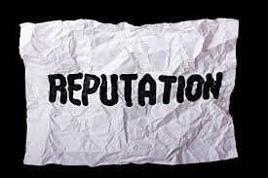 | 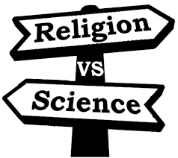
 | 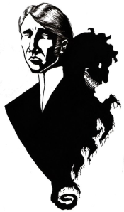  Dual nature of man

