

Before completing a consent form

Forms can be completed using a smartphone, but generally a desktop computer or laptop work best.

If you wish to decline the vaccination: This form will also need to be completed in the event that you have chosen not to have your child vaccinated, so we can update your child’s health records with your preference. Information regarding this such as GP and Child Health and will avoid you being contacted by us whilst your child is within the age group for these vaccinations.

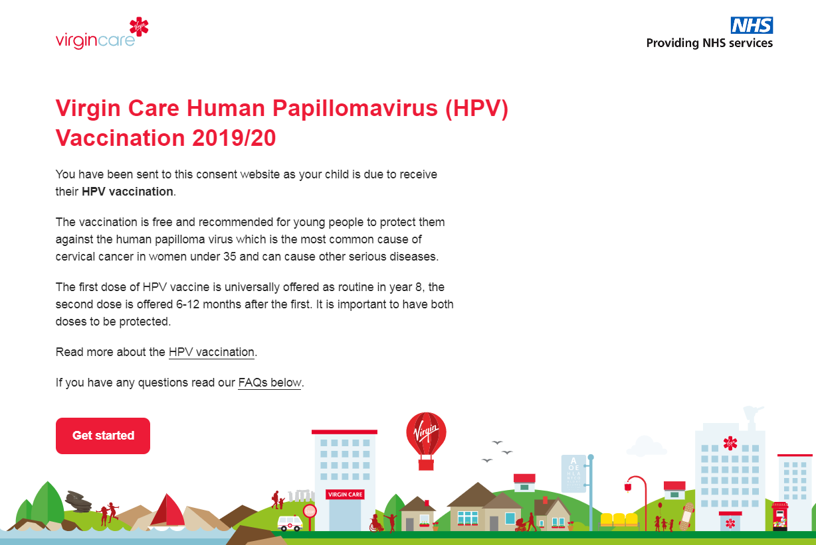
- When you press Ctrl & click on the link sent to you by the school you should immediately see a page like this:
Click this button and move on to the next step.
If you cannot see the button this means either the URL is wrong or the consent period has ended.
You can contact us on 033 33 219 884 and we can let you know when we can next vaccinate your child or fill in the form with you.
In this line the vaccination you will be consenting to will appear.

- School selection
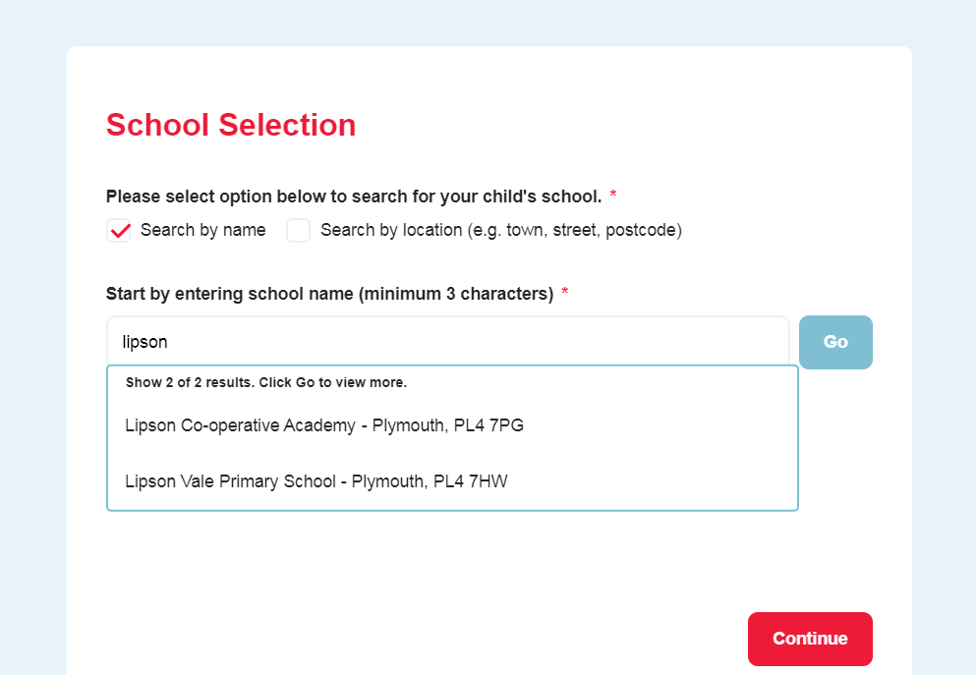
Please use the postcode if known, otherwise please type in the school name then click continue.
This is where the school names appear. Please ensure you click the correct school as some of the names are similar.

You will then get a confirmation on your screen to show which school you have selected. Double check it has the right address and the vaccination matches the one your child is due. If this is right please click the continue button.
- Entering your child’s information
Please ensure that you enter the correct date of birth for your child and not your own date of birth or that of a sibling.
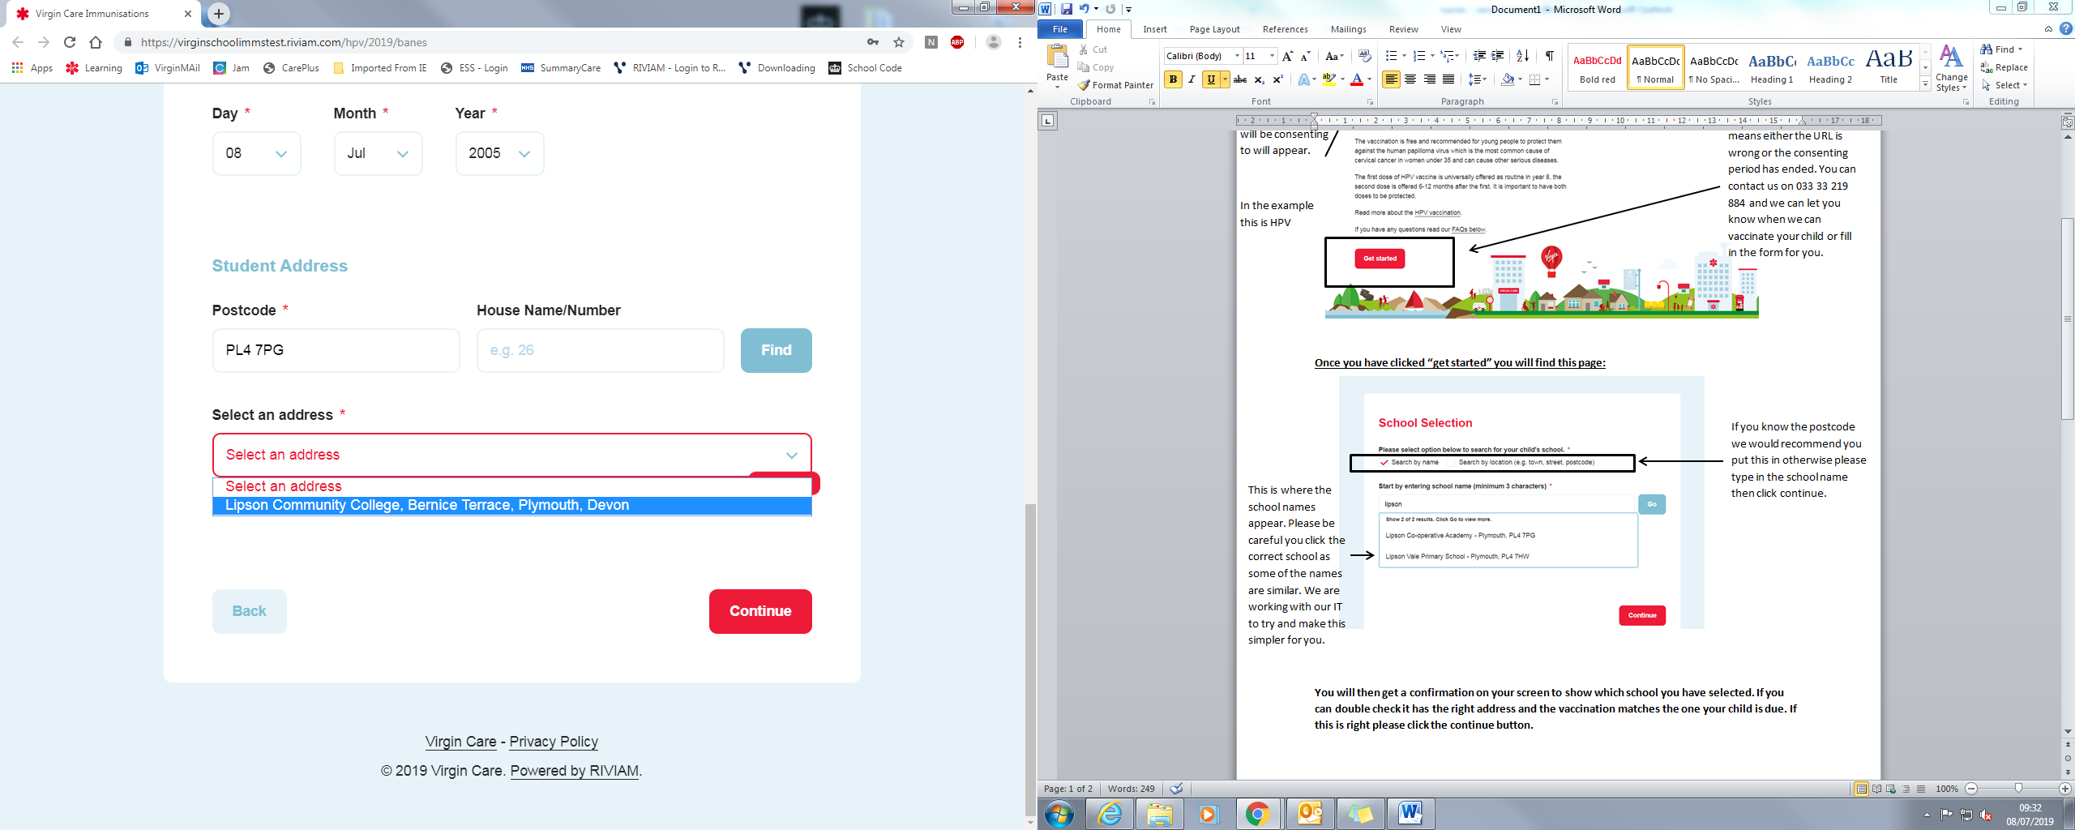
When typing in your postcode please do not leave a space afterwards or fill in too much information.
Once entered select an address should appear in the drop down menu.
If your postcode doesn’t appear you can click on another address then click enter manually and this should overwrite.
If not please check you have:
- Used capitals
- Not left a space after
- Used your correct postcode
Alternatively if all of these methods do not work, please use a postcode of a place nearby and let us know in a free text box in the consent form and if you wish we will pass this on to our IT team to look into.

- Submitting
Once the form has been submitted you will receive an email with a code per below. If you don’t receive one please check your spam box. If you still cannot find one please call us on the details below and we can check to see if we have received this.

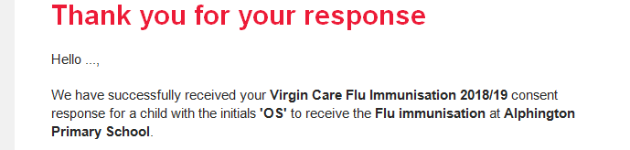
Contact details:
For revisit details please contact your school – they will be informed when we are coming back to school. As long as we have a consent form for your child we will automatically see them at the next visit. If you are unsure if you filled one out then please call us or email (see below).
For community clinics – if your child is due a community clinic appointment we will contact you ahead of the visit and book an appointment with you.
Phone line – 033 33 219 884 (8.30am – 4pm Monday to Friday)
Flu email – vcl.immunisationphnprimary@nhs.net
Diphtheria, Tetanus, Polio (DTP) +Men ACWY and HPV - vcl.immunisationphnsecondary@nhs.net

