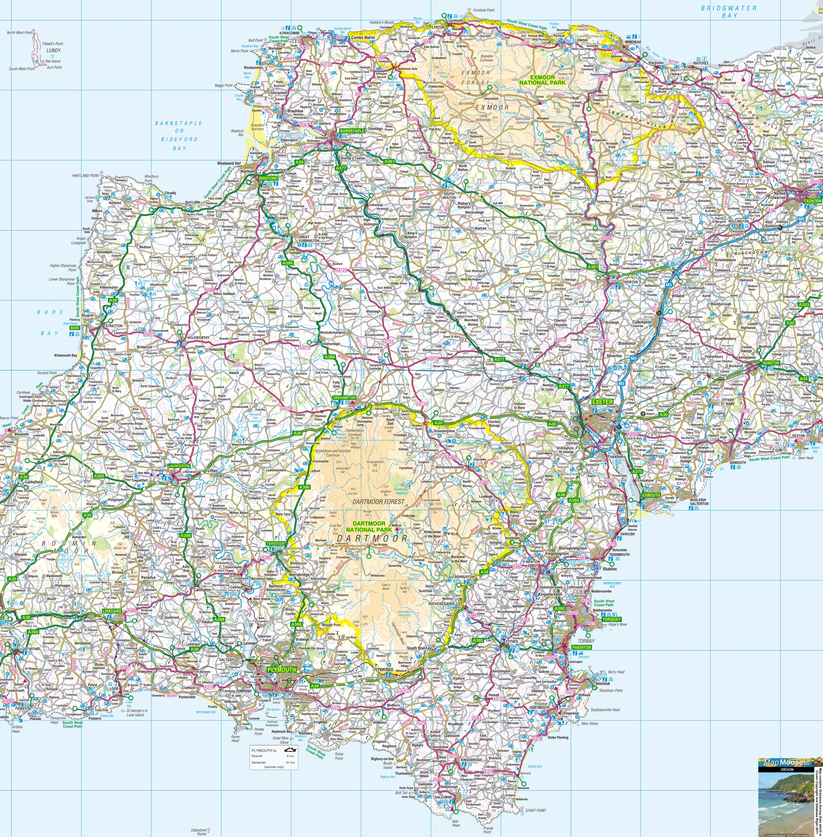

**The Spires College**

Torquay, TQ1 3PE

**Coombeshead Academy**

Newton Abbot, TQ12 1PT

**Newton Abbot College**

Newton Abbot, TQ12 2NF

**The Grove School**

Totnes, TQ9 5ED

**Paignton Community and Sports Academy**

Paignton, TQ3 3WA

**Churston Ferrers Grammar School**

Brixham, TQ5 0LN

**Dartmouth Academy**

Dartmouth, TQ6 9HW

**King Edward VI Community College**

Totnes, TQ9 5JX

**Kingswear Community Primary School**

Dartmouth, TQ6 0BJ

**Stoke Fleming Community Primary School**

Dartmouth, TQ6 0QA

**Blackawton Primary School**

Totnes, TQ9 7BE

**Teign School**

Newton Abbot, TQ12 3JG

**East Allington Primary School**

East Allington, TQ9 7RE

**Kingsbridge Community College**

Kingsbridge, TQ7 1PL

**Plympton Academy**

Plymouth, PL7 2RS

**Wembury Primary School**

Plymouth, PL9 0EB

**Coombe Dean School Academy Trust**

Plymouth, PL9 8ES

**Plymstock School**

Plymouth, PL9 9AZ

**Dunstone Primary School**  
Plymouth, PL9 8TQ

**Hele’s School**

Plymouth, PL7 4LT

**Woodlands Park Primary School**

Ivybridge, PL21 9TF

**Ivybridge Community College**

Ivybridge, PL21 0JA

**Callington Community College**

Callington, PL17 7DR

**Stowford School**

Ivybridge, PL21 0BG

**Christow Primary School**

Christow, EX6 7PE

**St Peter’s Church of England Aided School**

Exeter, TQ9 7BE

**South Devon UTC**

Newton Abbot, TQ12 2QA

**Rydon Primary School**

Newton Abbot, TQ12 3LP

**Teignmouth Community School**

Teignmouth, TQ14 9HZ

**Yealmpton Primary School**

Yealmpton, PL8 2HF

**Holbeton School**

Holbeton, PL8 1LT

**School Direct Partner Schools**

**2018-19**